**WEEK-5**

**Microservices**

Creating Microservices for account and loan

* **Account Microservice**

**AccountController.java**

**package** com.cognizant.account;

**import** org.springframework.web.bind.annotation.*;

@RestController

@RequestMapping("/accounts")

**public** **class** AccountController {

@GetMapping("/{number}")

**public** Account getAccountDetails(@PathVariable String number) {

**return** **new** Account(number, "savings", 234343);

}

**static** **class** Account {

**private** String number;

**private** String type;

**private** **double** balance;

**public** Account(String number, String type, **double** balance) {

**this**.number = number;

**this**.type = type;

**this**.balance = balance;

}

**public** String getNumber() { **return** number; }

**public** String getType() { **return** type; }

**public** **double** getBalance() { **return** balance; }

}

}

**AccountApplication.java**

package com.cognizant.account;

import org.springframework.boot.SpringApplication;

import org.springframework.boot.autoconfigure.SpringBootApplication;

@SpringBootApplication

public class AccountApplication {

public static void main(String[] args) {

SpringApplication.run(AccountApplication.class, args);

}

}

**OUTPUT:**

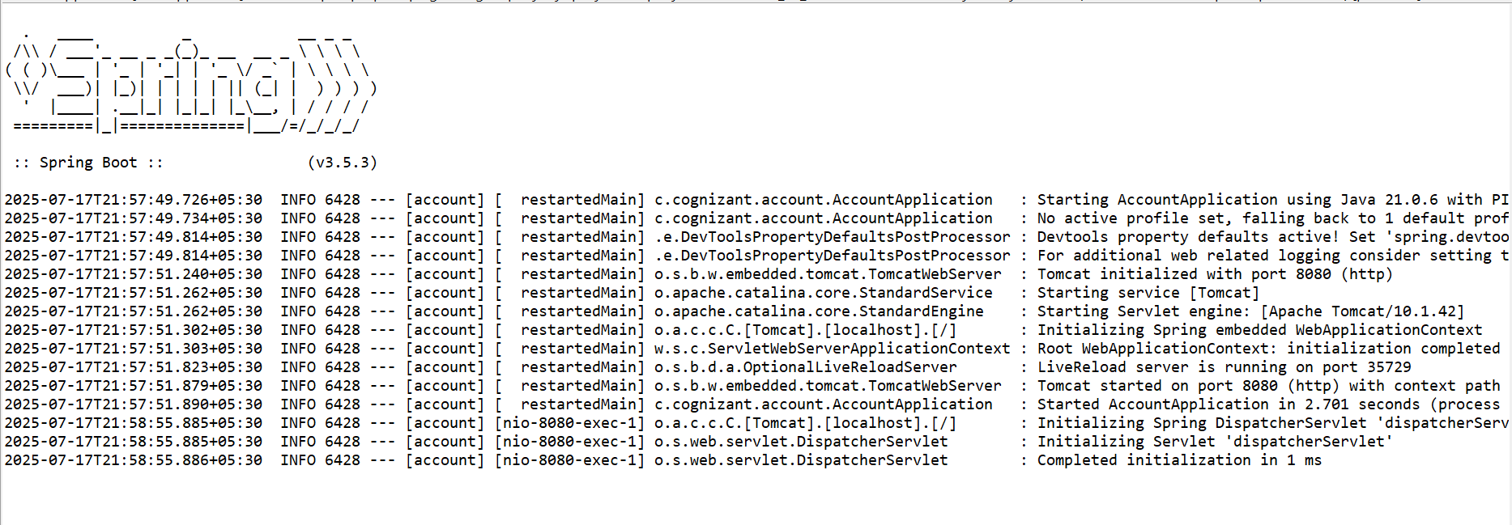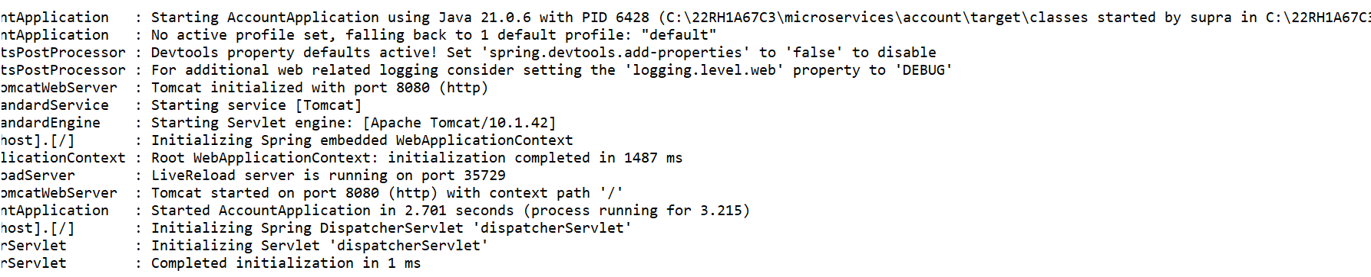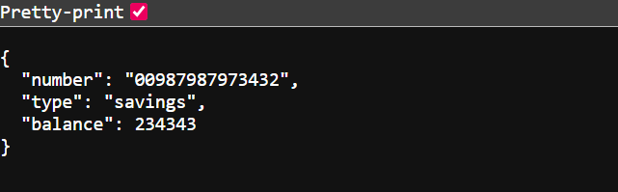

* **Loan Microservice**

**LoanController.java**

**package** com.cognizant.loan;

**import** org.springframework.web.bind.annotation.*;

@RestController

@RequestMapping("/loans")

**public** **class** LoanController {

@GetMapping("/{number}")

**public** Loan getLoanDetails(@PathVariable String number) {

**return** **new** Loan(number, "car", 400000, 3258, 18);

}

**static** **class** Loan {

**private** String number;

**private** String type;

**private** **double** loan;

**private** **double** emi;

**private** **int** tenure;

**public** Loan(String number, String type, **double** loan, **double** emi, **int** tenure) {

**this**.number = number;

**this**.type = type;

**this**.loan = loan;

**this**.emi = emi;

**this**.tenure = tenure;

}

**public** String getNumber() { **return** number; }

**public** String getType() { **return** type; }

**public** **double** getLoan() { **return** loan; }

**public** **double** getEmi() { **return** emi; }

**public** **int** getTenure() { **return** tenure; }

}

}

**LoanApplication.java**

package com.cognizant.loan;

import org.springframework.boot.SpringApplication;

import org.springframework.boot.autoconfigure.SpringBootApplication;

@SpringBootApplication

public class LoanApplication {

public static void main(String[] args) {

SpringApplication.run(LoanApplication.class, args);

}

}

**OUTPUT:**

